Name: pritam reddy machireddy  
Mis: 112316024  
Group: g6  
Branch: ece  
Date: 29-08-2024

# **C++/C program for Time Complexity plot of Bubble, Insertion and Selection Sort using Gnuplot**

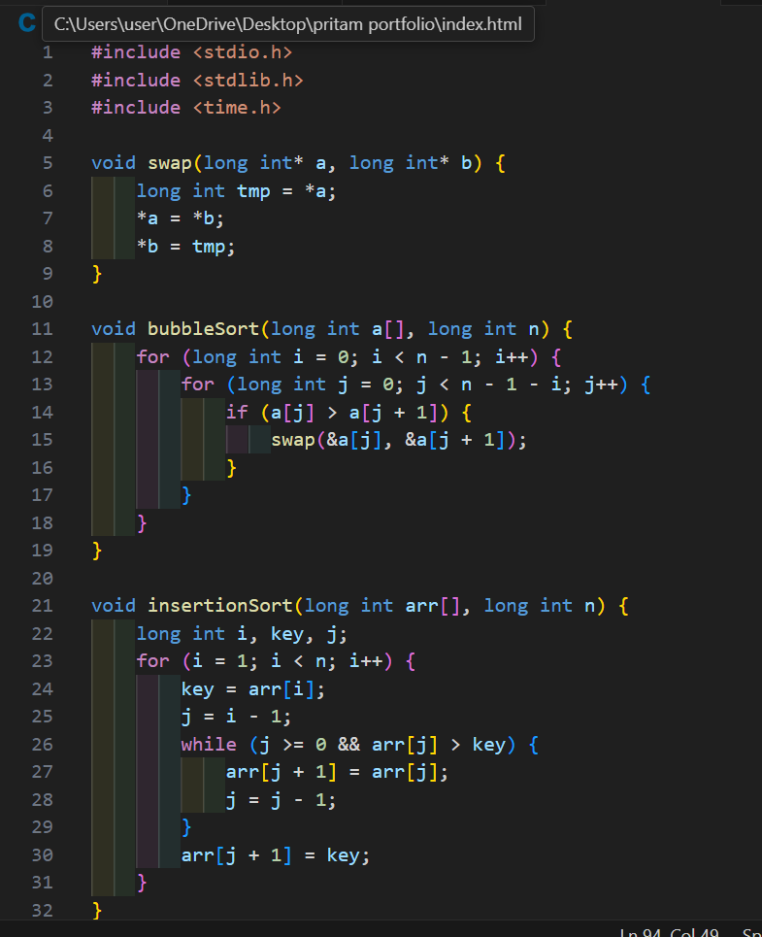

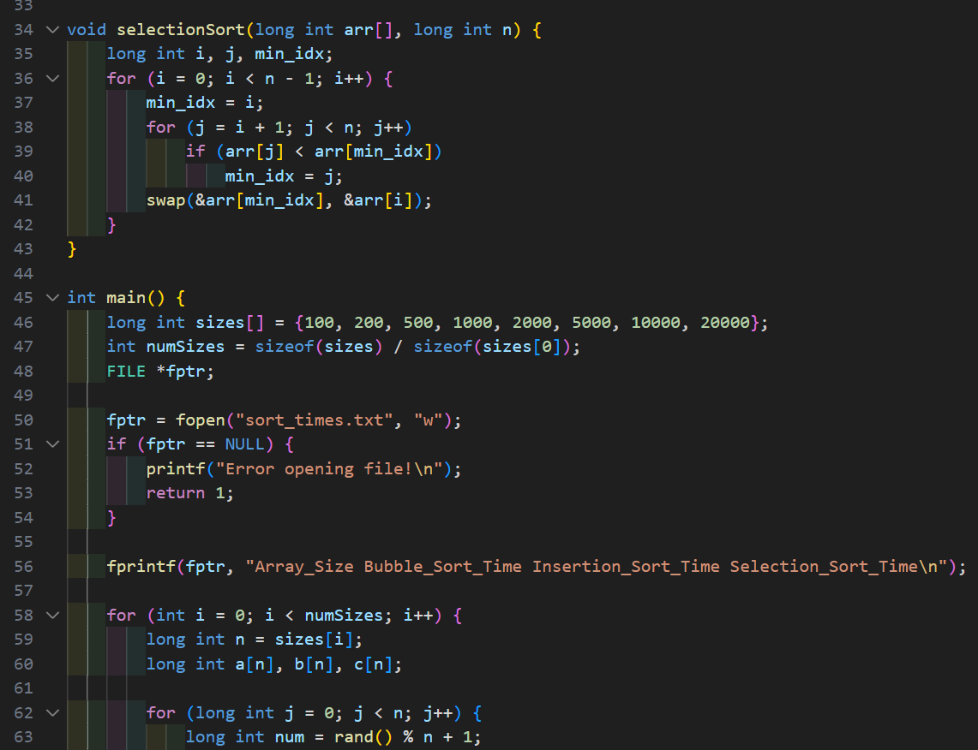

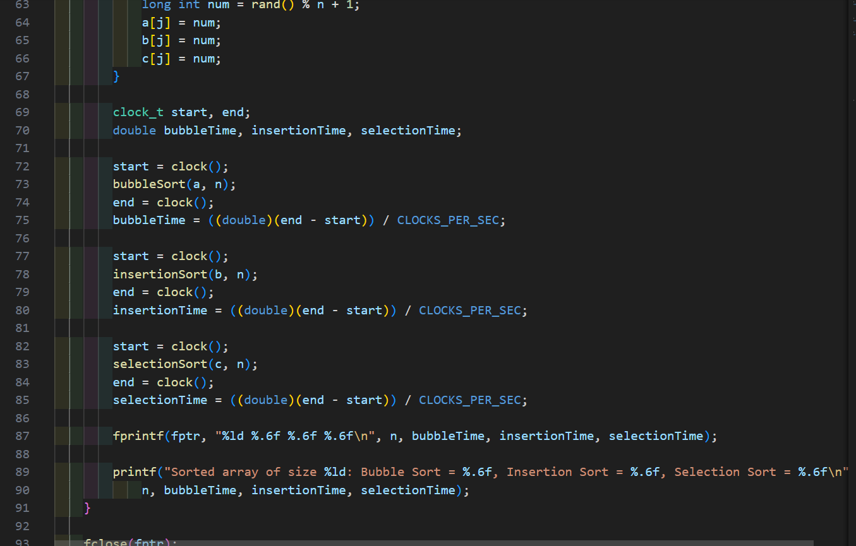

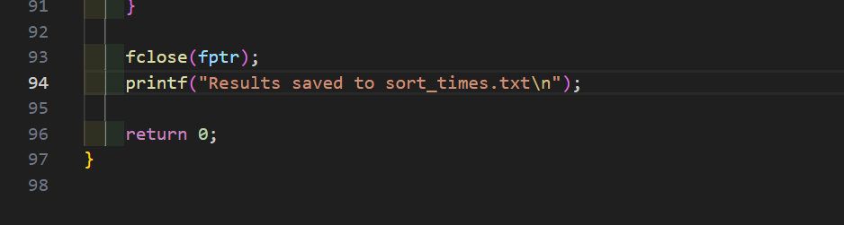

Output:

